Tableau Project



**Name** : Shruti Raju Bhujbal

**Project Name** : Blinkit Grocery Data Analysis

**Date** : 16-12-2024

**Technology** : Tableau

**Project Descriptions:**

* The visualization effectively presents the distribution of item types and their fat content, providing insights into consumer preferences.
* The sales data reveals that "Regular" items are the most popular, followed by "Low Fat" items.
* The sales trend over time suggests a positive trajectory, indicating potential growth in the market.
* The outlet location analysis highlights the importance of Tier 1 outlets in driving sales.

**Key Points**:

1. Item Type and Fat Content:
   * The dataset includes various item types with different fat content levels: Low Fat, Regular, and Soft Drinks.
   * The distribution of fat content across item types is visually represented using a mosaic plot.
2. Sales and Ratings:
   * The visualization shows a bar chart representing sales by item type and fat content.
   * The highest sales are observed for "Regular" items, followed by "Low Fat" and "Soft Drinks."
   * A line chart depicts the sales trend over time, indicating a slight increase in sales over the years.
3. Sale Count from Location:
   * A pie chart illustrates the distribution of sales across different outlet location types (Tier 1, Tier 2, and Tier 3).
   * Tier 1 outlets contribute the highest share of sales, followed by Tier 2 and Tier 3.
4. Item Weight:
   * The item weight is represented by a color scale on the mosaic plot, with darker colors indicating higher weight.

**Snapshots** :

Dashboard of Blinkit Grocery Sales :

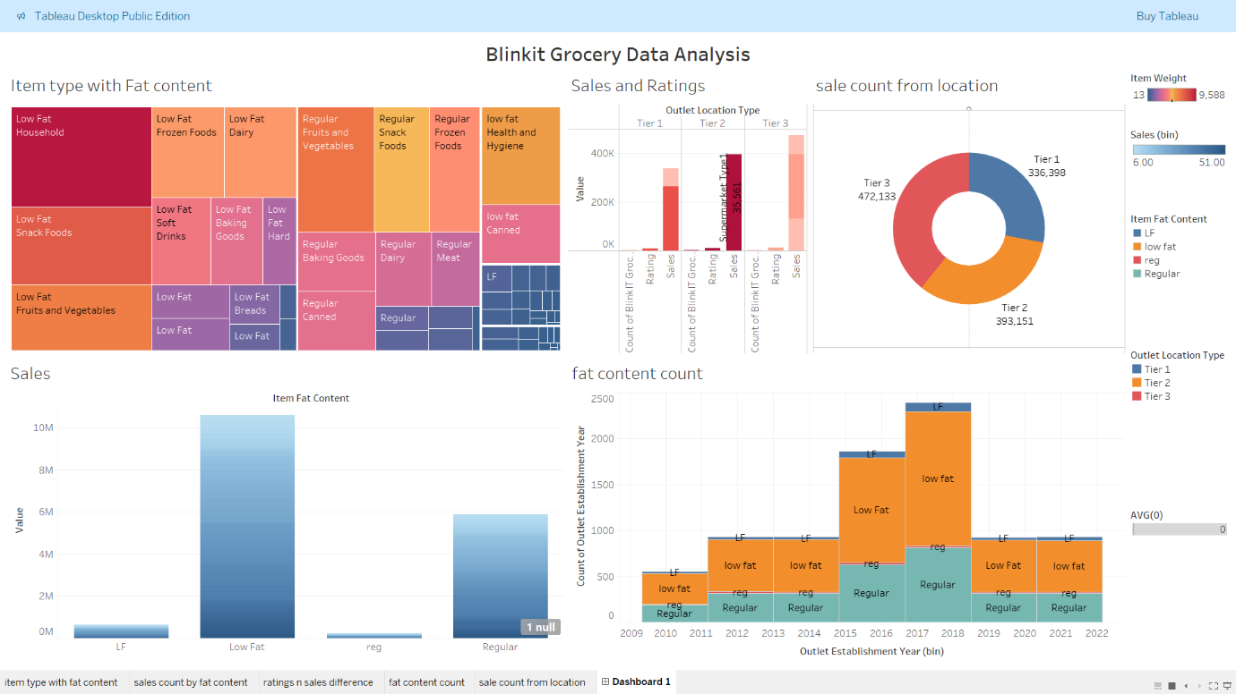

**Conclusion**:

* Based on the data, it can be concluded that consumers generally prefer "Regular" items, followed by "Low Fat" items.
* The increasing sales trend suggests that Blinkit Grocery is experiencing growth and expansion.
* Tier 1 outlets play a crucial role in generating sales and should be prioritized for marketing and promotional activities.

**Additional Considerations**:

* To gain deeper insights, it would be helpful to analyze sales data by specific product categories or brands.
* Exploring the impact of factors like pricing, promotions, and seasonal variations on sales could provide valuable information for strategic decision-making.
* Conducting a comparative analysis with competitors' data could reveal competitive advantages and areas for improvement.